EXERCISE-16

16.Design TM using simulator to accept the input string anb2n

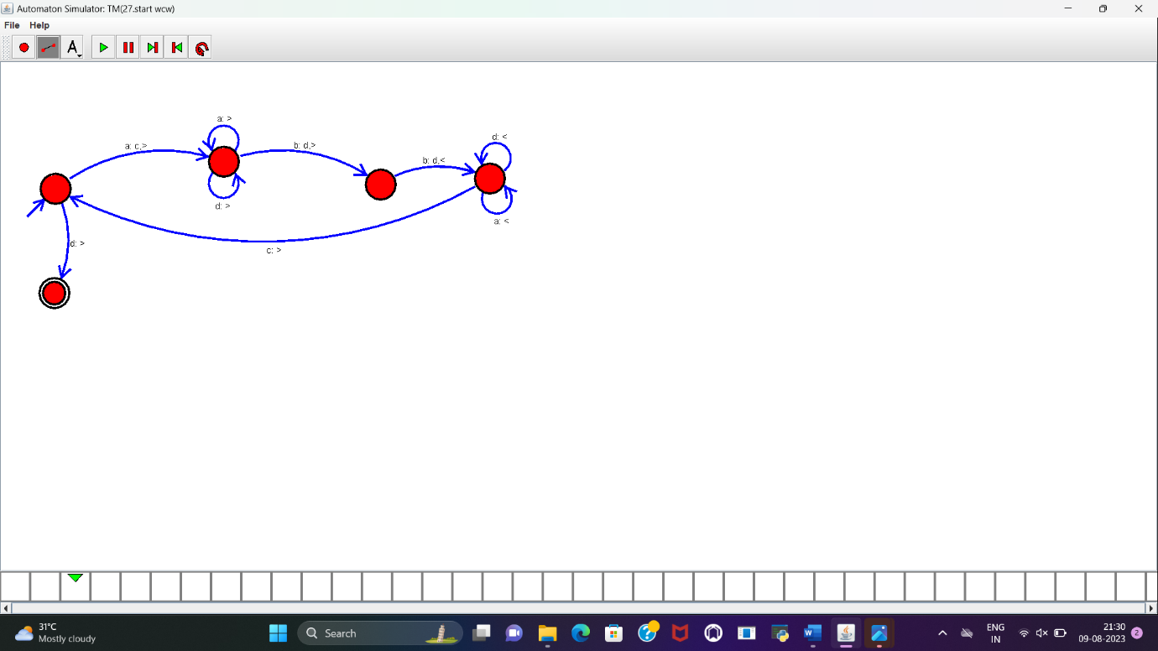

RESULT:

TM to accept the string a^nb^2n is designed and implemented successfully.